Department of Statistics

The Wharton School

University of Pennsylvania

Statistics 603 August 2011
Assignment 3 Solutions

1. True or False?
- In practice, samples are always selected from the target population.
False. Ideally, the sampled population is the same as the target population but this is not always the case.
- The Central Limit Theorem does not hold for an iid sample from a non-Normal population.
False; the CLT holds for all populations, Normal and non-Normal.
- When the sample size is greater than 1, the standard error of the mean is less than the standard deviation of the sample.
True; the standard error of the mean is 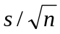 which is less than s when n > 1.
- The standard error is an estimate of the standard deviation of a sampling distribution.
True; this is the definition of standard error.
- A 95% CI will contain about 95% of the data.
False; a 95% CI (confidence interval) covers a parameter 95% of the time. (A 95% tolerance interval will contain about 95% of the data).
- Suppose 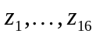 iid ~ N (μ, 10²). (Recall that this notation means σ = 10.) Then has a 95% chance of being within 5 units of μ.
True; ~ 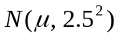 so that 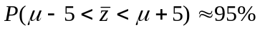.
- The t-statistic measures a distance in units of standard errors.
True; the t-statistic measures the distance between a statistic and a parameter in units of standard errors.

2. Basic Calculations for the One-Sample Problem: For a sample of size n = 100, suppose the sample mean is 18.0 and the sample standard deviation is 5.0.
(a) Find the standard error of the mean.
(b) Find a 95% CI for the population mean.
- Test the hypothesis that the population mean is 16.0.

(a) 5/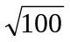= .5
(b) A 95% CI for  is (18 – 2(.5), 18 + 2(.5)) = (17,19).
(c) Reject 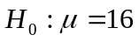 at the .05 level because 18 is more than 2 standard errors from 16. Equivalently, the t-statistic t = (18-16)/.5 = -4 , and 4 > 2.

3. The Influence of a Survey Question: Two surveys are conducted to measure the effect of an advertising campaign to promote the use of a particular brand of detergent. In the first survey, interviews ask randomly selected housewives if they use that particular brand of detergent. In the second, interviewers ask randomly selected housewives what brand of detergent they use. Would you expect the surveys to reach similar conclusions? Explain.

People will often tend to respond differently in a survey where the brand of interest is identified. For example, a tendency to please increases their tendency to say yes.

4. Inference Using an iid Normal Sequence: The file AT&T.jmp contains the 84 monthly returns on AT&T from January 1961 through December 1967. Let 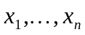 stand for this data.
(a) Is it reasonable to assume that iid ~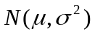? Why?
(b) Provide estimates for the parameters of this model.
(c) Find the standard error of your estimate of μ.
(d) Use JMP to find an exact 95% CI for μ .
(e) Find an approximate 95% CI for using the 2 standard error rule-of –thumb. How does this compare with your confidence interval in (d)?
(f) Find an approximate 95% prediction interval for the return in January 1968, namely x_{n+1}.
How does this compare with your confidence intervals in (d) and (e)?
(g) Use JMP to test the hypothesis H₀: μ = 0.
(h) Test H₀: μ = 0 using the 2 standard error rule-of-thumb. Does your conclusion agree with your answer to (g)?

(a) Yes. The Normal quantile plot below suggests we can assume a Normal density. There is no discernable pattern of deviation from the 45 degree line.
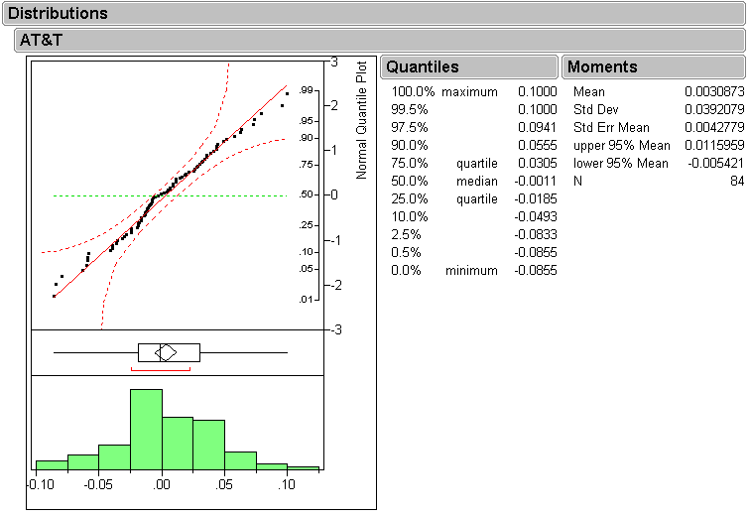
(b) From the same JMP output, we obtain from the column “Moments” that
= .0030873 and 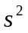 = .00154.
(c) The standard error of our estimate of μ is 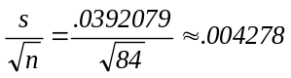 which is also referred to
in the JMP output as Std Error Mean.
(d) From the output in part (a), we see the 95% confidence interval is (-.00542,.011596)
(e) 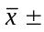2 std error = .003087 2 (.004278) = ( -.005469,.011643), which is very close to our answer in part (d). Notice the rule of thumb confidence interval is slightly wider than the one from part (d).
(f) The prediction interval in this case is 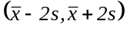= .0030872(.0392079) = (-.075329, .081503) which is much wider than the confidence intervals from part (d) and (e). Remember the reason this is wider is that individual values are more variable than averages.
(g) In the JMP window that results from Analyze > Distribution, click the red diamond next to the “AT&T” title, select Test Mean > OK to obtain:
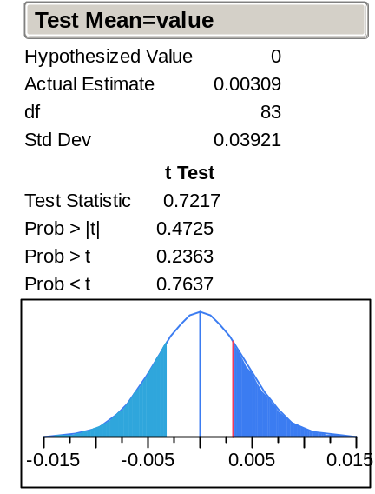
The p-value (the measure of rarity of the observed data if H₀: μ = 0 is true) is indicated by “Prob>|t|” and has a value of 0.4725. This is so much larger than the conventional cutoff of 0.05 that the null hypothesis H₀: μ = 0 cannot be rejected by a long shot.
(Ignore the last two lines of the above block of numbers; they refer to “one-sided tests; in class we introduced only “two-sided tests”.)

h) The 2 standard error rule-of –thumb (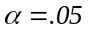) is to reject when the |t statistic|>2. In this case our t-statistic is 0.7217 hence we cannot reject the null hypothesis that 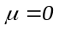. This is in agreement with the result from part (g).

5. The Two Sample Problem: The analysis in Module 8 of the data in UsedCars.JMP indicated a significant difference between the selling prices of the BMW four wheel and standard models.
a) Suppose a dealer claimed that the average selling price of the four-wheel drive models was $3000 higher than the average selling price of the standard models. Do the data in UsedCars.JMP support such a claim?
b) These cars were not randomized to the two groups. We also know that newer cars sell for more than older cars. Has this effect distorted through confounding the conclusions you reached in (a)?
a) The 95% CI for the average price difference, namely ($619, $2780) does not contain $3000, so the claim can be rejected at the .05 level of significance. The data do not support the claim.
b) No. The average age of the cars in the two groups is identical. Age has not confounded the comparison in (a). (Had, for example, the xi models been newer, then this difference in age might have explained the difference in prices.)
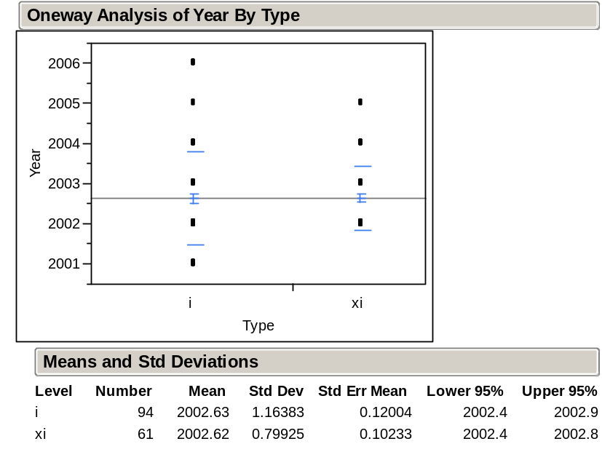

6. The Influence of Sample Size on Significance: Laurel and Hardy each perform independent experiments to test the same hypothesis H₀: μ = 10. Coincidentally, they both come up with the same point estimate = 11. However, Hardy claims his result is significant at the .001 level (i.e. his p-value is less than .001), whereas Laurel claims he cannot reject at even the .05 level. Speculate as to the disparity between their findings.
A likely explanation is that they used different sample sizes. Hardy used a large sample size that led to a small standard error , and Laurel used a small sample size that led to a large standard error. This would cause Hardy’s t-statistic to be much larger than Laurel’s. (This example illustrates how the statistical quantification of uncertainty influences our conclusions: Laurel’s smaller sample size leaves him with greater uncertainty and does not allow him to infer that the true mean is different from 10. Note that he does NOT infer that the true mean equals 10, only that there is not sufficient evidence to say that it is not equal to 10!)

